Architectural Context
Ryan Coon
SWE-530
Professor Mohamed Mneimneh
May 6, 2026

Architectural Diagrams
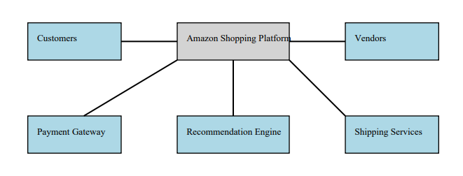
Logical View
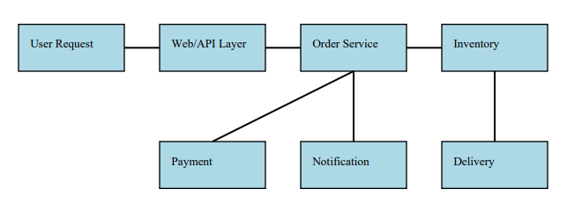
Process View
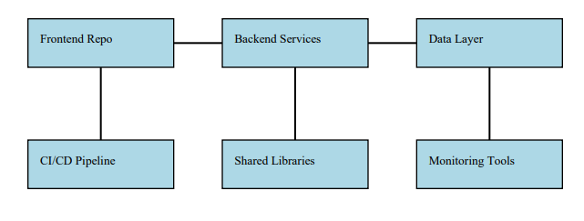Development View
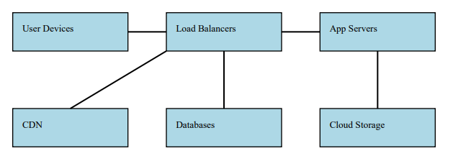
Physical View
Questions
Technical Role within Amazon
The Amazon Shopping platform is the cornerstone of Amazon’s retail business, serving as the primary interface for millions of customers globally to discover, purchase, and receive products. Technically, it functions as a massive, distributed, multi-sided platform that connects consumers, third-party sellers, payment processors, and logistics providers. It is designed to handle extremely high volumes of traffic and transactions, often scaling dynamically to accommodate seasonal spikes such as Prime Day or Black Friday.
At its core, the platform operates as a microservices-based ecosystem, where independent services manage discrete business capabilities such as product catalog management, search and recommendation, order processing, payment authorization, and fulfillment coordination. This modular architecture enables Amazon to innovate rapidly, deploy updates frequently, and isolate failures without impacting the entire system.
The platform also acts as a data ingestion and analytics engine, collecting vast amounts of behavioral data that feed into machine learning models for personalized recommendations, dynamic pricing, fraud detection, and inventory forecasting. This data-driven approach enhances user experience and operational efficiency.
In summary, the Amazon Shopping platform is not merely an e-commerce website; it is a complex, scalable, and resilient software system that orchestrates the entire retail value chain, enabling Amazon to maintain its competitive edge and operational excellence.
Contextual Influences Affecting the System
The architecture and operation of the Amazon Shopping platform are shaped by a variety of contextual factors spanning business, global, economic, environmental, and societal domains.
Business Influences
Amazon’s business model is centered on customer obsession, low prices, and vast selection. The platform must support a seamless shopping experience that encourages repeat purchases and customer loyalty. The “Flywheel Effect” drives architectural decisions: lower prices attract more customers, which attracts more sellers, which increases selection and lowers costs further. This virtuous cycle demands a platform that can scale elastically and maintain low latency under heavy load.
The platform also supports Amazon’s third-party marketplace, which accounts for a significant portion of sales. This requires robust APIs and integration points for sellers to manage inventory, pricing, and orders, necessitating a flexible and extensible architecture.
Global Influences
Operating in over 200 countries, Amazon must comply with diverse regulatory regimes, including GDPR in Europe and CCPA in California. This mandates a “Privacy by Design” approach, where user data handling is transparent, secure, and compliant with local laws(IBM, n.d.). The platform must support data localization, user consent management, and mechanisms for data deletion.
Localization extends beyond compliance; the platform must handle multiple currencies, languages, tax regimes, and shipping rules. This complexity influences the design of modular services that can be customized per region without fragmenting the codebase.
Economic Influences
Amazon operates in a highly competitive retail market with thin margins. The platform must optimize operational costs, including infrastructure and logistics. Cloud-native design on AWS enables cost-effective scaling, while microservices allow teams to optimize individual components for performance and cost.
Economic fluctuations, such as supply chain disruptions or inflation, require the platform to adapt pricing, inventory, and fulfillment dynamically. This necessitates real-time data processing and flexible business rules engines.
Environmental Influences
Sustainability is increasingly important to Amazon’s corporate strategy. The platform integrates with logistics systems to optimize delivery routes, reduce packaging waste, and support carbon footprint tracking. These environmental goals influence the design of algorithms and data models that prioritize eco-friendly fulfillment options.
Societal and Ethical Influences
Amazon’s platform impacts society by shaping consumer behavior and employment patterns. Ethical considerations include ensuring fairness in search and recommendation algorithms, avoiding bias that favors Amazon’s private-label products over third-party sellers. Transparency and auditability of these algorithms are critical to maintain trust. Data privacy and security are paramount, given the sensitive nature of payment and personal data. The platform must implement strong encryption, access controls, and monitoring to prevent breaches.
Additionally, the platform must consider accessibility to serve users with disabilities, complying with standards such as WCAG (Web Content Accessibility Guidelines).
Stakeholders, Their Needs, and Organizational Impact
The Amazon Shopping platform serves a diverse set of stakeholders, each with distinct needs and expectations.
End Consumers
Consumers expect a fast, reliable, and personalized shopping experience. They demand intuitive search, relevant recommendations, secure payment options, and timely delivery. The platform addresses these needs through scalable front-end services, machine learning-driven personalization, and integration with payment gateways and logistics.
Third-Party Sellers
Sellers require robust APIs for inventory management, pricing updates, order fulfillment, and analytics. They expect fair competition and visibility into their performance. The platform provides seller portals, API endpoints, and reporting tools to meet these needs.
Internal Teams
Amazon’s internal teams product managers, developers, operations, and customer service, rely on the platform’s modular architecture to innovate rapidly and maintain high availability. The “Two-Pizza Team” organizational model aligns with microservices ownership, where small teams own specific services end-to-end, fostering accountability and agility.
Regulatory Bodies
Regulators require compliance with data protection, tax, and financial reporting laws. The platform incorporates compliance modules and audit trails to meet these requirements.
Logistics and Fulfillment Partners
These stakeholders depend on real-time order data and inventory synchronization to optimize warehouse operations and delivery routes. The platform integrates with Warehouse Management Systems (WMS) and transportation management systems (TMS) to ensure smooth fulfillment.
Influence on Software Architecture and SDLC Integration
The combination of technical roles, contextual influences, and stakeholder needs profoundly shapes Amazon Shopping’s software architecture and development processes.
Architectural Impact
- Microservices and Modularity - To handle global complexity and diverse stakeholder needs, the platform is decomposed into loosely coupled microservices. This modularity supports independent development, deployment, and scaling, enabling rapid innovation without risking system-wide failures.
- Event-Driven and Asynchronous Processing - To maintain responsiveness and resilience, the platform employs event-driven architectures with message queues and event buses. This design supports eventual consistency and decouples services, essential for handling high transaction volumes and distributed fulfillment.
- Cloud-Native Deployment - Leveraging AWS, the platform uses container orchestration, serverless functions, and managed databases to achieve elasticity, fault tolerance, and geographic distribution.
- Security and Compliance by Design - Security is embedded at every layer, with encryption, identity and access management, and continuous monitoring. Compliance modules ensure adherence to regional laws and ethical standards.
- Data-Driven Personalization - Machine learning models are integrated into the architecture to provide personalized recommendations, dynamic pricing, and fraud detection, enhancing user experience and operational efficiency.
SDLC and External Integration
- Continuous Integration/Continuous Deployment (CI/CD) - The platform’s modular architecture supports automated testing and deployment pipelines, enabling thousands of daily releases. This agility is critical to respond to market changes and fix issues rapidly.
- Infrastructure as Code (IaC) - Deployment environments are defined and managed through code, ensuring consistency and enabling rapid provisioning of resources.
- API-First Design - Open and well-documented APIs facilitate integration with third-party sellers, payment gateways, logistics providers, and regulatory systems, creating an extensible ecosystem.
- Observability and Monitoring - Comprehensive logging, metrics, and tracing are integral to the architecture, enabling proactive issue detection and performance optimization.
The Amazon Shopping platform exemplifies a sophisticated, resilient, and scalable software system that is tightly aligned with Amazon’s business strategy and global operational realities. Its architecture reflects a careful balance of modularity, cloud-native design, and event-driven processing to meet the demands of millions of users and thousands of sellers worldwide (Amazon, n.d.).
Contextual influences from economic pressures and global regulations to environmental sustainability and ethical considerations, drive architectural decisions that prioritize flexibility, compliance, and transparency. The diverse stakeholder ecosystem shapes the platform’s features and organizational structure, fostering a culture of ownership and rapid innovation.
Finally, the integration of modern SDLC practices and external entities ensures that the platform remains agile, secure, and extensible, enabling Amazon to maintain its leadership in the highly competitive e-commerce landscape.

References
Amazon. (n.d.). Architecture Resources | AWS. Amazon Web Services, Inc. https://aws.amazon.com/architecture/
Bass, L., Clements, P., & Kazman, R. (2021). Software Architecture in Practice. Addison-Wesley.
IBM. (2016). What is GDPR? | IBM. Ibm.com. https://www.ibm.com/products/cloud/compliance/gdpr
Kleppmann, M. (2017). Designing Data-Intensive Applications. “O’Reilly Media, Inc.”
Kruchten, P. B. (1995). The 4+1 View Model of architecture. IEEE Software, 12(6), 42–50. https://doi.org/10.1109/52.469759

